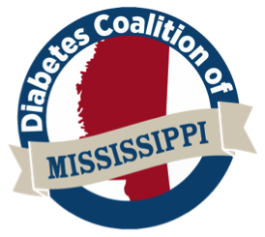

May 13, 2021

Dear Board of Directors,

It’s with the greatest pleasure that I recommend Dr. Ashley Ellis for the CBDCE Board of Directors position.
As Director of the Diabetes Coalition of Mississippi, I’ve had the honor of working closely with Dr. Ellis, as she serves as our management workstream chair. The coalition is comprised of three workstreams—management, prevention, and policy—all of which, under strong leadership, move the work of the organization forward.

With her extensive professional background, Dr. Ellis has gained not only the knowledge to actively engage in complex, niche conversations but, perhaps more importantly, she’s spent time with patients to learn their stories and see their needs.

Since January, Dr. Ellis has demonstrated an eagerness to participate and commit to the Diabetes Coalition board and management workstream. In fact, I consider her as one of the more dependable and innovative thinkers of the group, always assisting in planning and executing projects/quarterly meetings. Amongst the many rich conversations Dr. Ellis has contributed to, she recently spoke on medication access at our virtual quarterly meeting, articulated clear objectives for the management workstream, shared insightful thoughts on inclusive terminology, and continues to establish the groundwork to meet the previously mentioned objectives. She also volunteered to write our first website blogpost, which is now published, on diabetic patients, new COVID guidelines, and healthy coping.

Examples of her projects are to “provide sample business plans and an online calculator for DSME centers to project upfront costs, revenues and returns on investment” and to “host a DSME accreditation and reimbursement boot camp” for educators that need coaching in this area. These are two of five objectives that she’s created and began working on.

While Dr. Ellis does professionally display excellence, her character shines just as bright. As I mentioned before, she’s very dependable and generous with her time and thoughts. She’s well-connected and informed, an active thinker, compassionate, curious, and personable.

Please feel free to contact me by email at Madison.moore@horizonprofessionalservices.com or by phone at 601-602-5011 if you have any questions. It’s a joy to work with Dr. Ellis, and I am confident in her leadership on any team.

Sincerely,

Madison Moore
Director of Diabetes Coalition of Mississippi

