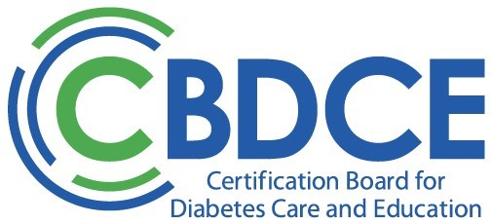

CBDCE Mentorship Program – Program Discontinued
June 2026
Thank you for your interest in participating in becoming a mentor in the CBDCE Mentorship Program. This message is to let you know that CBDCE has made the difficult decision to discontinue the Mentorship Program. While this was not an easy decision, it has become clear that external challenges - including increasing difficulty in obtaining approval to place mentees within hospital systems and academic centers – are preventing the program from achieving its goals and facilitating successful mentorship matches.
While we are sunsetting this program, we remain committed to exploring new opportunities to support current and potential certificants seeking guidance and support, and we hope to relaunch a new mentorship initiative in the future. We will keep you informed as those opportunities develop.
Your willingness to give back to the diabetes care and education community is deeply appreciated, and we look forward to finding new ways to channel that generosity.
Thank you again for your dedication to the profession. If you have any questions, please contact the administrative office.

